1.

(a)  
ronju999@DESKTOP-R0S8D89:~/assignment01$ touch 20301261_1.txt 20301261_2.txt 20301261_3.txt

ronju999@DESKTOP-R0S8D89:~/assignment01$ touch 20301261_4.txt

ronju999@DESKTOP-R0S8D89:~/assignment01$ mkdir jamil1 jamil2

ronju999@DESKTOP-R0S8D89:~/assignment01$ mv 20301261_1.txt 20301261_2.txt 20301261_3.txt jamil1

ronju999@DESKTOP-R0S8D89:~/assignment01$ ls

20301261_4.txt jamil1 jamil2

ronju999@DESKTOP-R0S8D89:~/assignment01$ cd jamil

-bash: cd: jamil: No such file or directory

ronju999@DESKTOP-R0S8D89:~/assignment01$ cd jamil1/

ronju999@DESKTOP-R0S8D89:~/assignment01/jamil1$ cp 20301261_1.txt 20301261_2.txt ../jamil2/

ronju999@DESKTOP-R0S8D89:~/assignment01/jamil1$ cd ..

ronju999@DESKTOP-R0S8D89:~/assignment01$ mkdir jamil3

ronju999@DESKTOP-R0S8D89:~/assignment01$ cp -r jamil1 jamil3/

ronju999@DESKTOP-R0S8D89:~/assignment01$ cd jamil3/

ronju999@DESKTOP-R0S8D89:~/assignment01/jamil3$ ls -l

total 0

drwxr-xr-x 1 ronju999 ronju999 512 Feb 29 21:47 jamil1

ronju999@DESKTOP-R0S8D89:~/assignment01/jamil3$ chmod 755 jamil1/

ronju999@DESKTOP-R0S8D89:~/assignment01/jamil3$ cd ..

ronju999@DESKTOP-R0S8D89:~/assignment01$ ls

20301261_4.txt jamil1 jamil2 jamil3

ronju999@DESKTOP-R0S8D89:~/assignment01$ mv jamil3 ../

ronju999@DESKTOP-R0S8D89:~/assignment01$ ls

20301261_4.txt jamil1 jamil2

ronju999@DESKTOP-R0S8D89:~/assignment01$ rm -r *

ronju999@DESKTOP-R0S8D89:~/assignment01$ ls

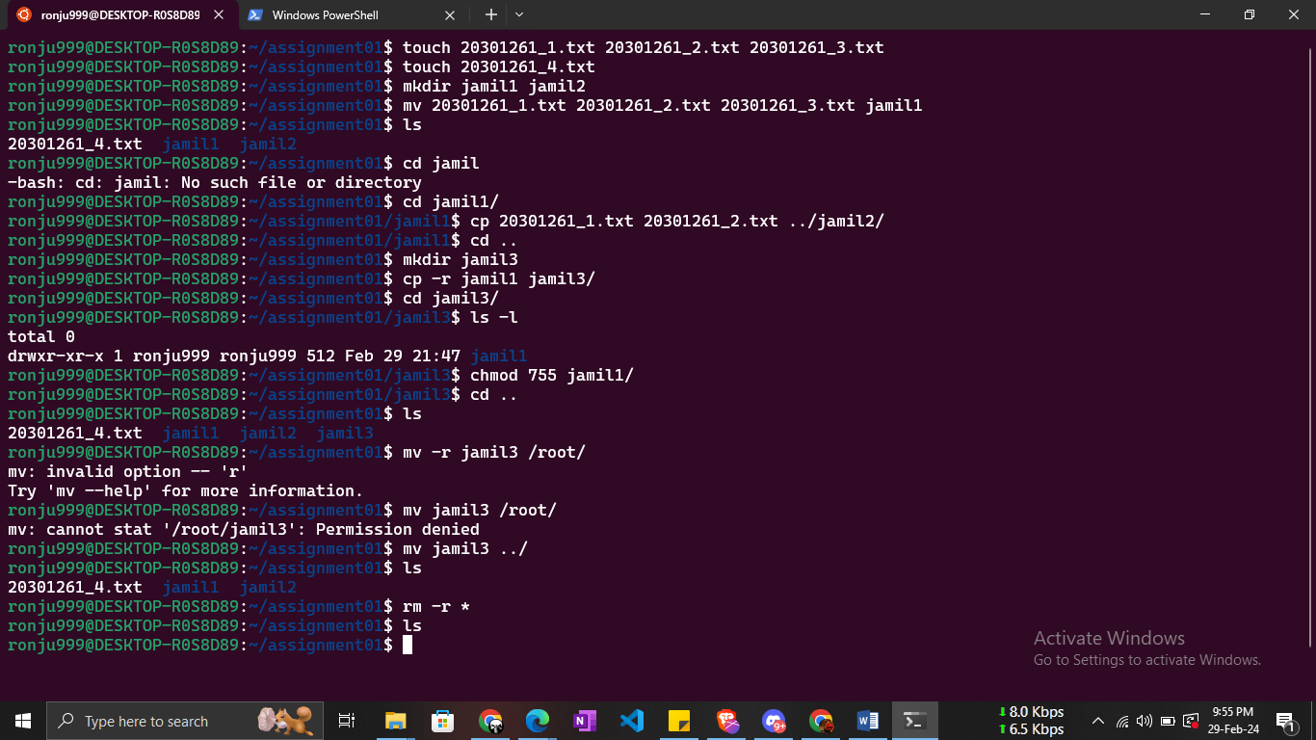

(b)

Touch courses.txt

Cat > courses.txt

CSE321 OPERATING SYSTEMS 04 FLA

CSE421 COMPUTER NETWORKS 03 TSD

CST201 LUXURY AND OPPRESSION IN A GLOBALIZED WORLD:NOSEDIVE 01 MHF

HUM217 NARRATIVES OF TRUTH AND LIES 01 MHF

grep -c "CSE" course.txt

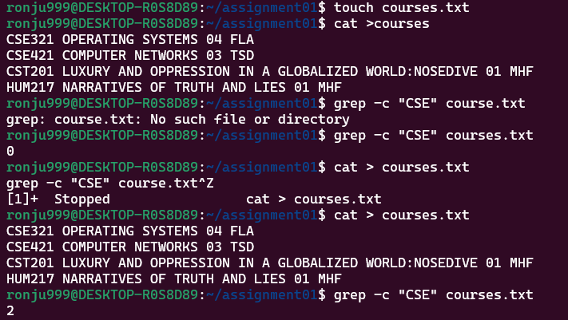

(c)

sudo chmod o+x /root/

cd root/

sudo ls -a

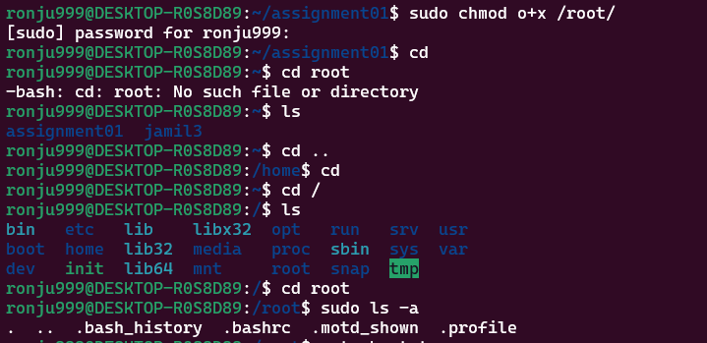

(d)

sed -n "5, 17p" abc.txt

